NAME: ____________________________

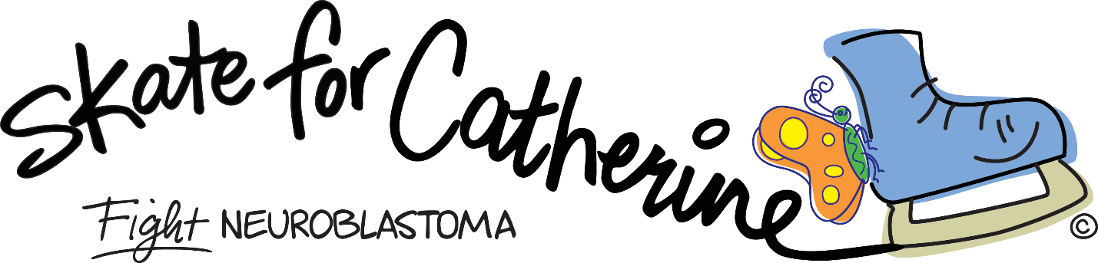

Skating Challenge
I will be “skating for Catherine” to raise money for The Catherine Elizabeth Blair Memorial Foundation. Money raised will go to research for the childhood cancer neuroblastoma. Help me win the GOLD medal for collecting the most money!
NOTE: Pledge $ due by February 28.
Name | Pledge (per lap) | Pledge x number of laps | Single donation option | Total | Paid
Number of laps completed: _____________ Total amount raised: ________________

www.BlairFoundation.org
** The Catherine Elizabeth Blair Memorial Foundation is a component fund of the Greater Washington Community Foundation. All gifts are fully tax deductible under the Community Foundation's 501(c)3 status. Tax ID # 23-7343119

